# 5.1 Eigenvectors and Eigenvalues

### Definition

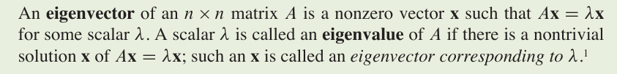

### Theorem 1

The eigenvalues of a triangular matrix are the entries on its main diagonal.

### Theorem 2



# 5.2 The Characteristic Equation

## Determinants

Page 277

### Theorem



### Theorem 3 from (Chapter 3)

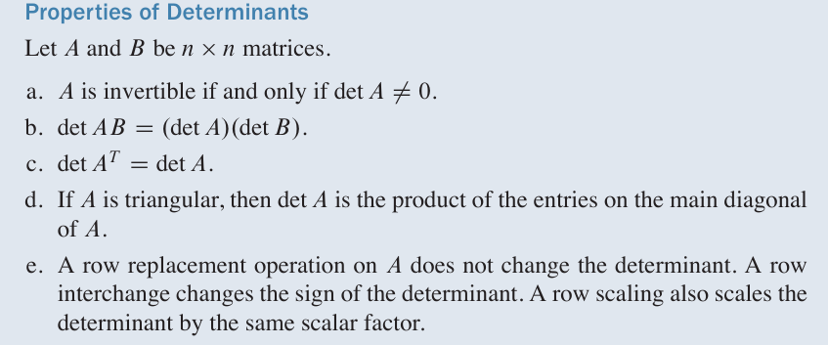

## The Characteristic Equation

The scalar equation det ( *A –* λ*I* ) = 0 is called the **characteristic equation** of *A.*



If *A* is an  *n* x *n* matrix, then det ( *A –* λ*I* ) si a polynomial of degree *n* called the **characteristic polynomial** of *A*.

## Similarity

If *A* and *B* are *n* x *n matrices,* then *A* **is similar to** *B* if there is an invertible matrix *P* such that *P*-1*AP* = *B*, or, equivalently, *A* = *PBP*-1. Writing *Q* for *P*-1, we have *Q*-1*BQ* = *A*. So *B* is also similar to *A*, and we say simply that *A* and *B* **are similar**. Changing *A* to *P-1AP* is called a **similarity transformation.**

### **Theorem 4**

### 

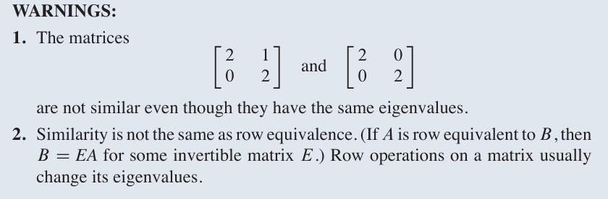

# 5.3 Diagonalization

A square matrix *A* is said to be **diagonalizable** if *A* is similar to a diagonal matrix, that is, if *A = PDP*-1 for some invertible matrix *P* and some diagonal matrix *D.*

### Theorem 5 – The Diagonalization Theorem

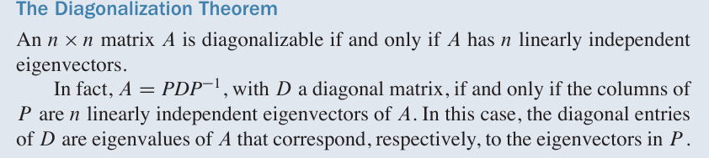In other words, *A* is diagonalizable if and only if there are enough eigenvectors to form a basis of ℝn. We call such a basis an eigenvector basis of ℝn.

## Diagonalizing Matrices

See example 3 on page 285.

### Theorem 6

An *n* x *n* matrix with *n* distinct eigenvalues is diagonalizable.

Note: It is *not necessary* for an *n* x *n* matrix to have *n* distinct eigenvalues in order to be diagonalizable.

## Matrices Whose Eigenvalues Are Not Distinct

### Theorem 7

